

USER MANUAL

PREPARED BY :

ahmad aiman bin ahmad zaki (2017797061)

syamsol azim bin ZAHARUDIN (2017971497)

NUR AQILAH BINTI HASBULLAH (2017969253)

FARAH nur IZZANA BINTI abd rahim (2017764889)

Table of Contents

INTRODUCTION 3

OVERVIEW 4

HOMEPAGE 4

ADD USER 5

LOGIN 6

INTERN 6

COMPANY 12

ADVISOR 14

APIs 15

# INTRODUCTION

The User Manual contains all essential information for the user to make full use of the student internship system. This manual includes a description of the system functions and capabilities, contingencies and alternate modes of operation, and step-by-step procedures for system access and use.

# OVERVIEW

## HOMEPAGE

This is the homepage of the website when the users open the website. Users must login or register to link to the next page.



Register button

Login Button

## ADD USER

To access the page, for the new users need to register by enter their email and password. Users need to choose their roles. Click the submit button and users must fill in all the sections to submit the form.

Option to choose the roles :

1. Intern
2. Advisor
3. Company

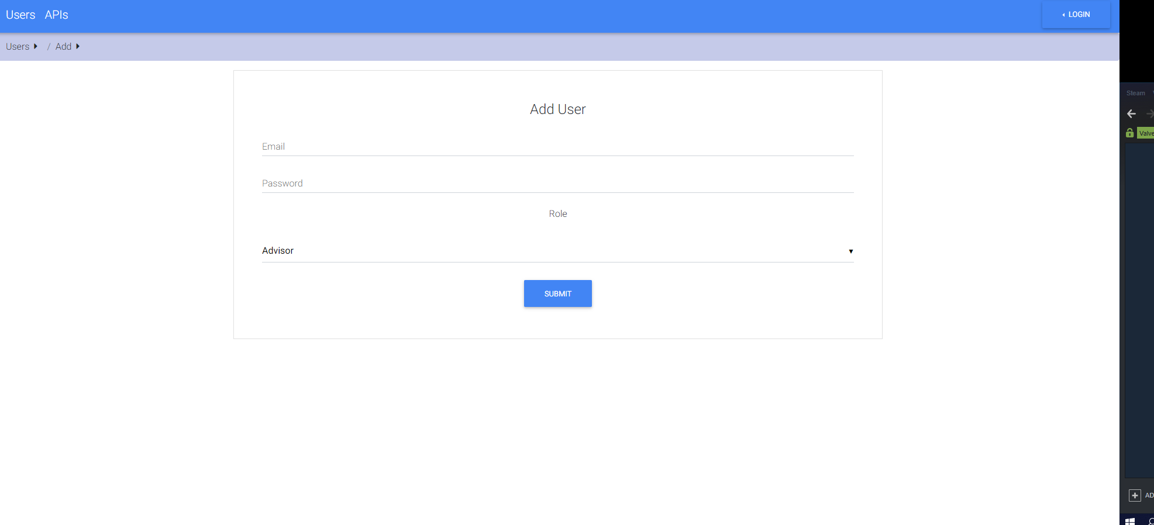

Submit button

Click this to choose role

## LOGIN

Users can access to their profile by insert their email and password. Users will be linked to their profile.

## INTERN

1. 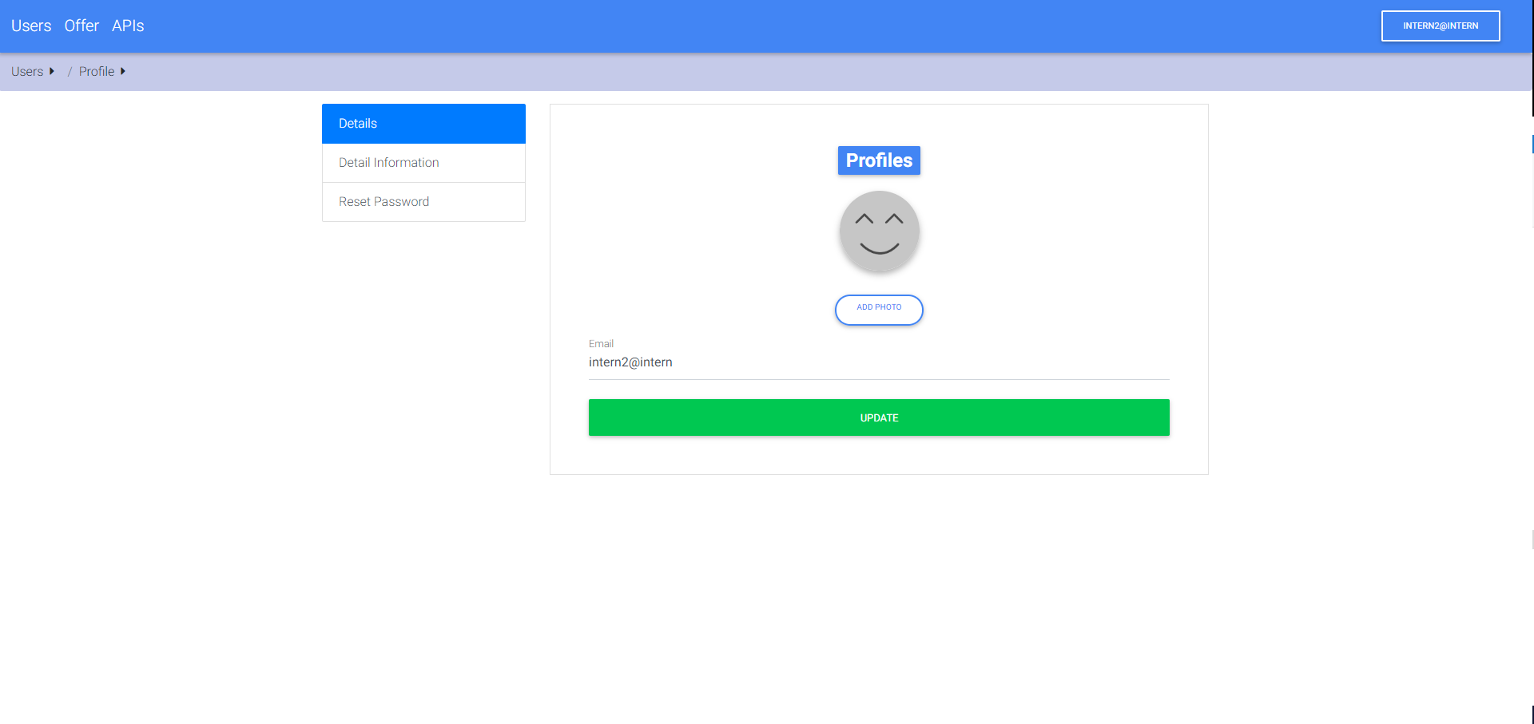If the users enter as an intern, users will be linked to their profile.

Click this to add profile photo.

Click this to update email

1. Intern users can edit or update their detail information.

Fill the form :

1. First and last name
2. Phone number
3. Address
4. Postcode
5. State

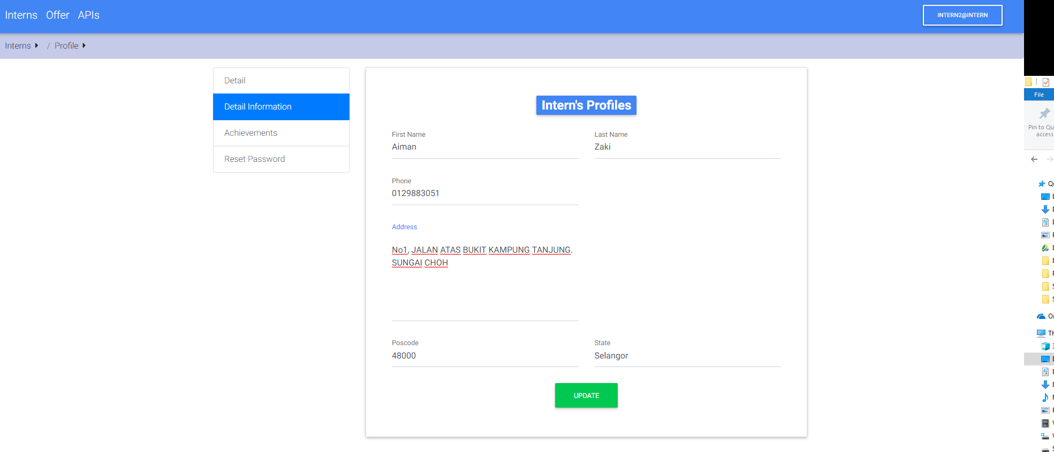

Click update button to save the current information

1. Intern users can update their current status in the achievements page.

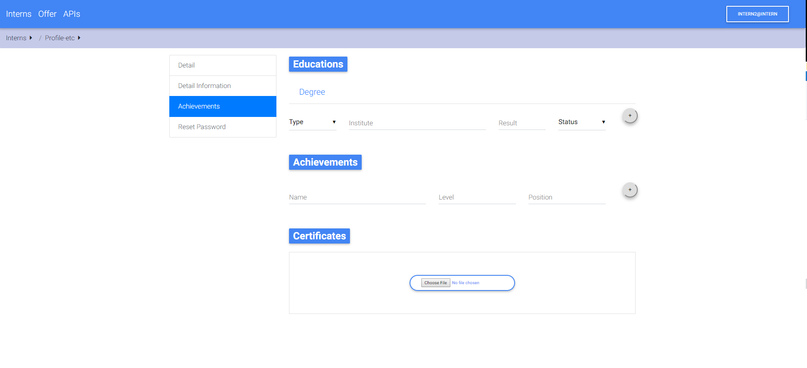

Click this button to add additional educations and achievements



Click choose file button to add the certificates

1. The file upload allows interns to choose by directly loading the file from their computer.
2. Intern users can apply and view the listed offers. Interns can search for specific internship.

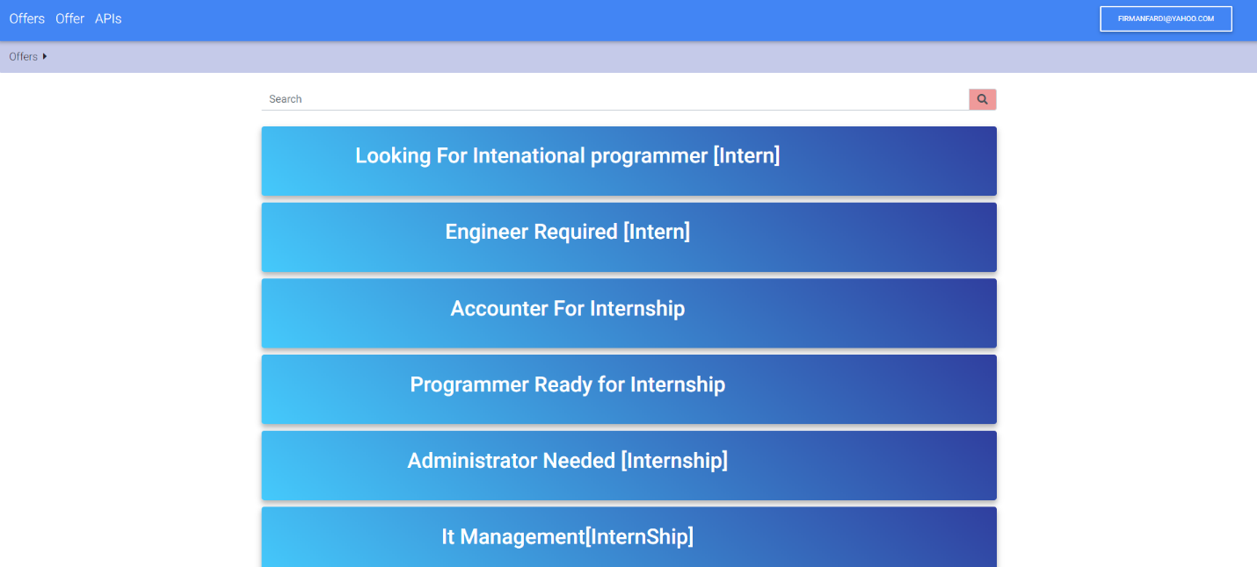

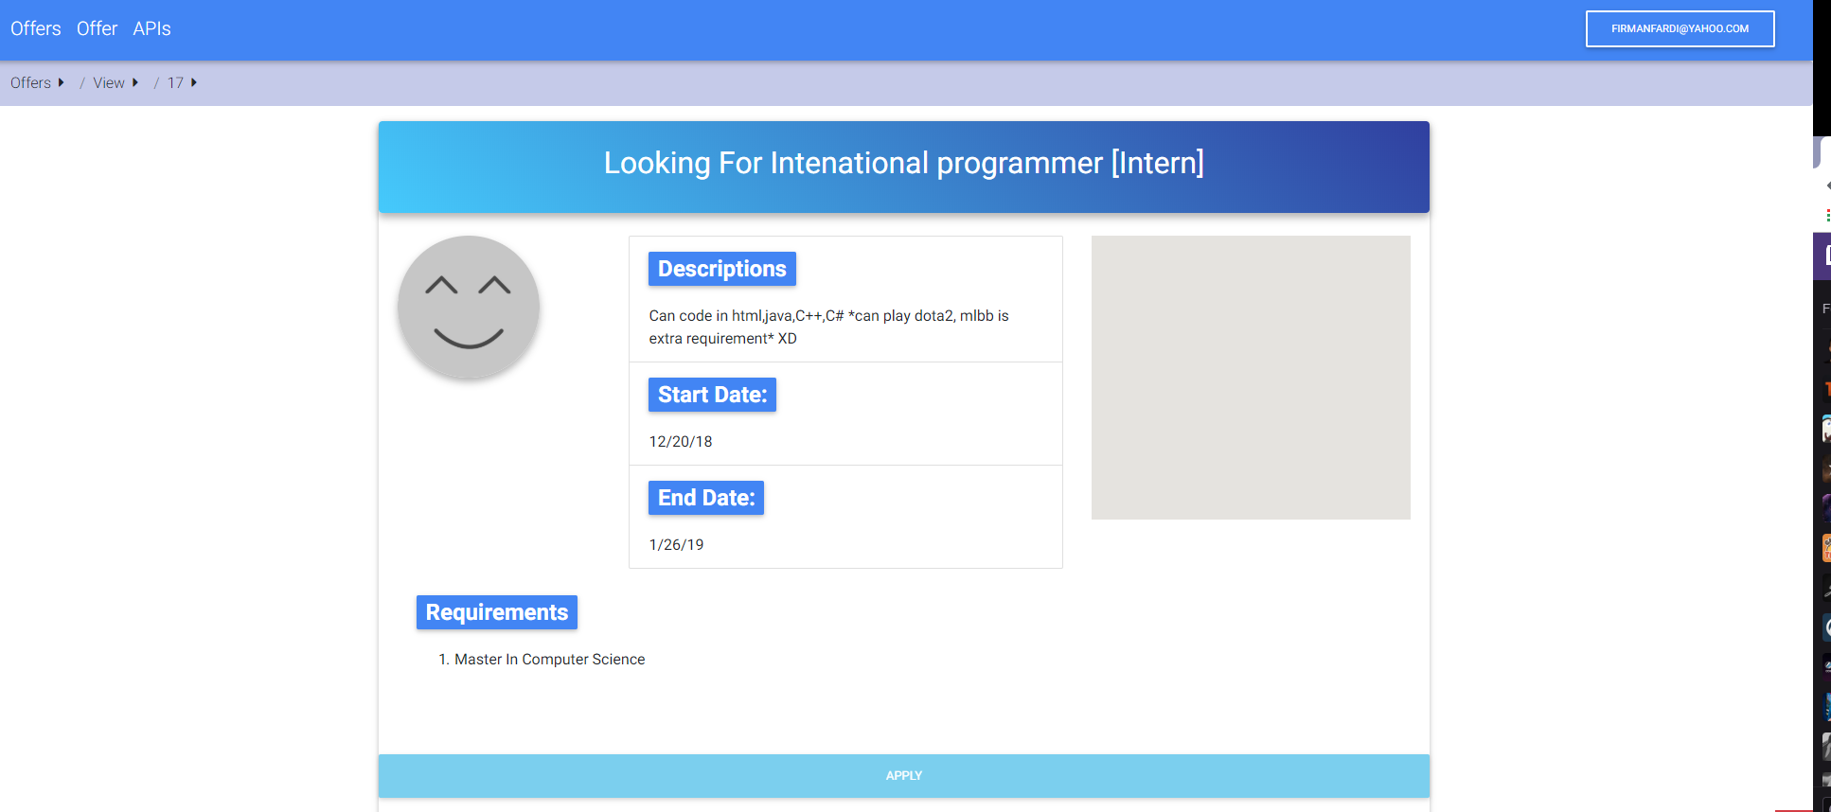

Click apply button to apply the offer

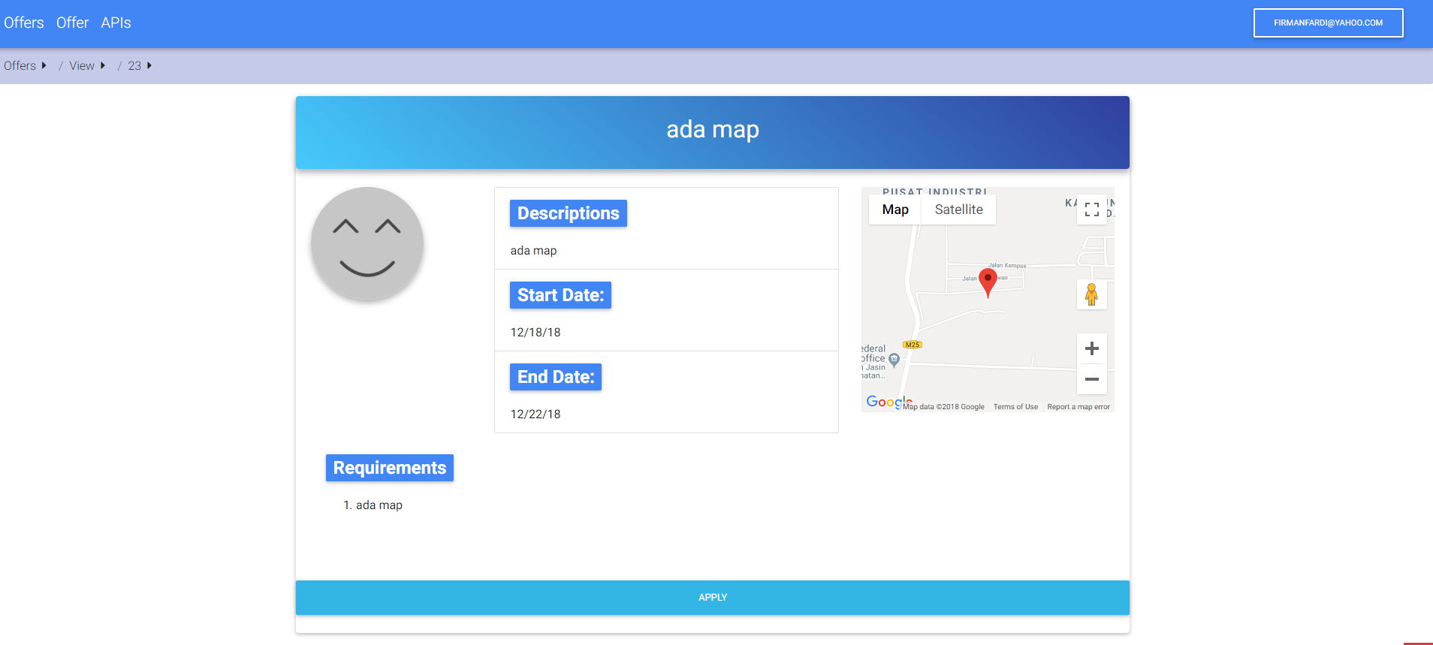

Click the map to view the details location of the company

1. Interns can view their list of applications.

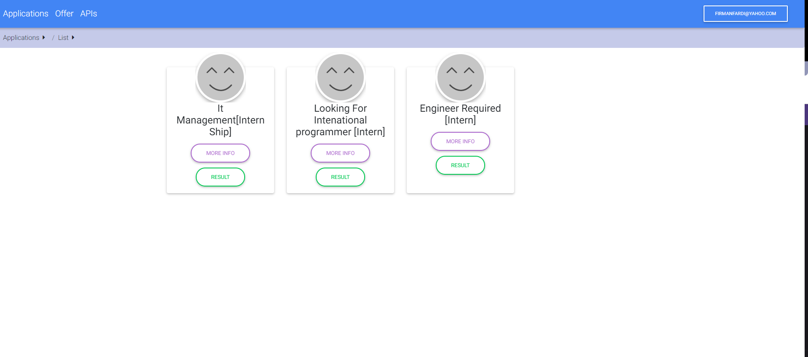

Click more info to view the details of the internship offer

Click result button to view the result of the application of the intern

## COMPANY

1. If users enter as a company, users will be linked to company list of internship offers. Company can edit the offer, view the applicants or delete the offers by click the according buttons.

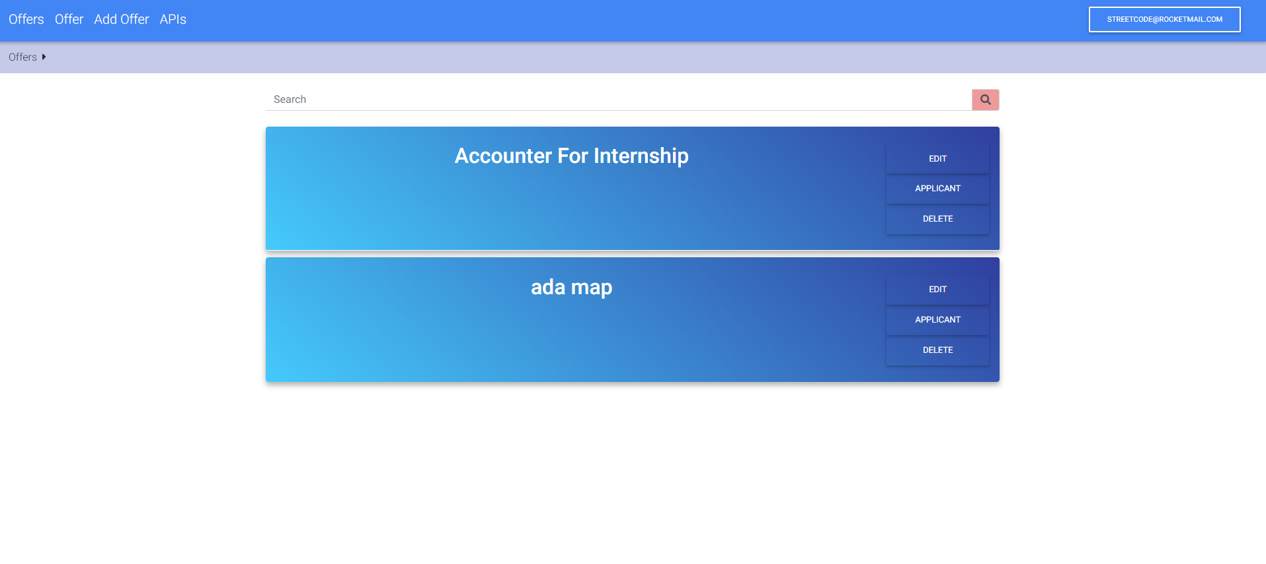

1. 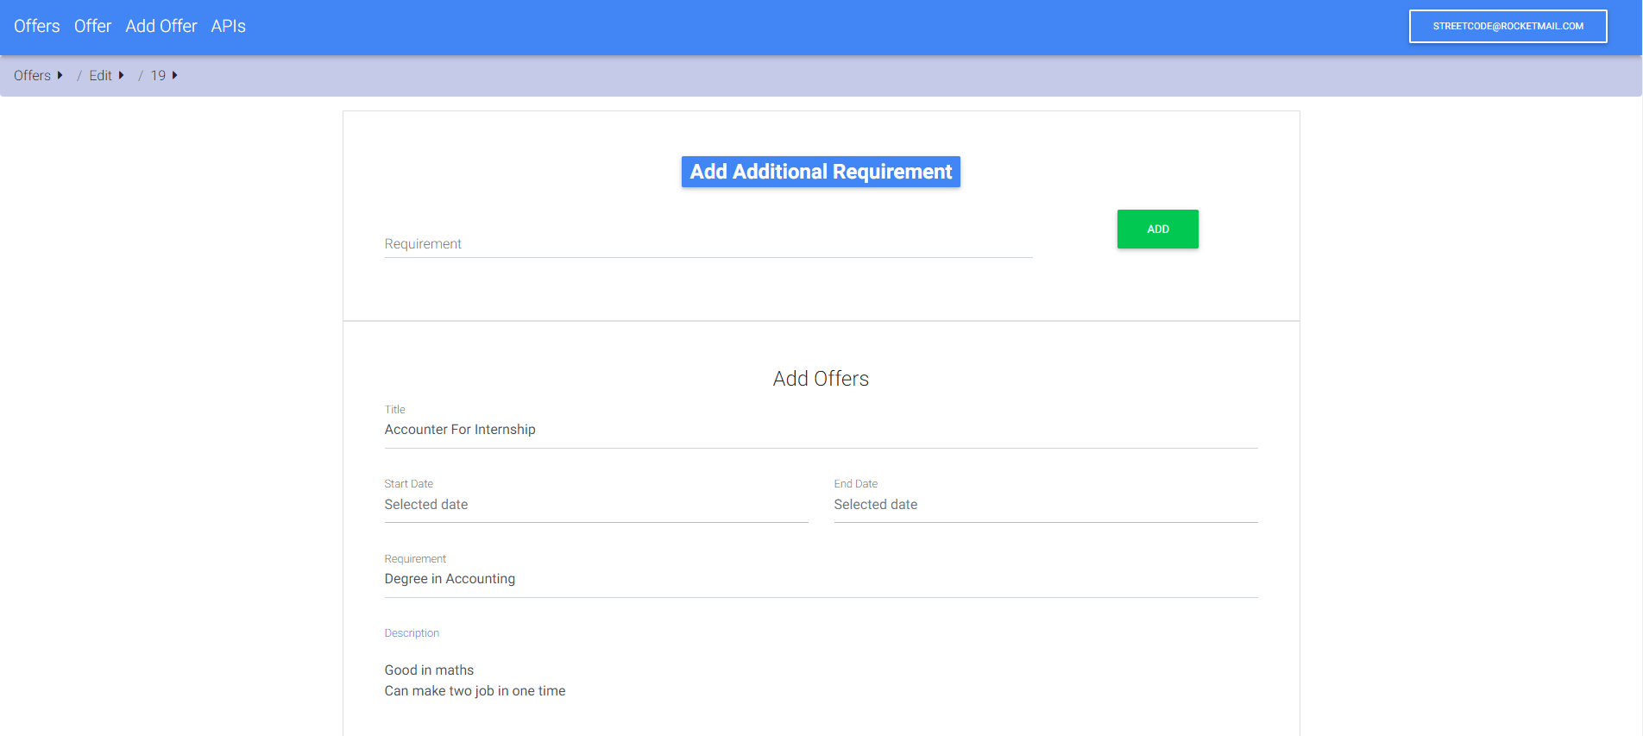Company can edit the details about the internship offers.

Click add button to add additional requirements of the offer

1. Company users can view the list of applicants of the internship offer.

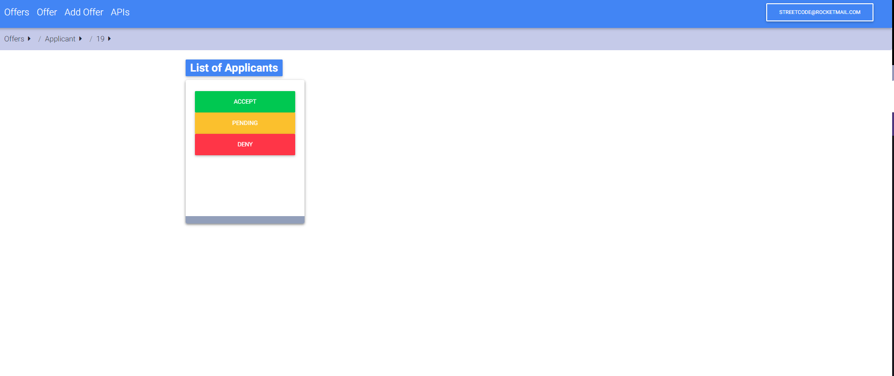

Click deny button to reject the applicant

Click accept button to accept the applicant

Click pending button to list applicant into waiting list

1. Company can add new internship offer. Fill the form and submit the offer. Make sure all the section contains with complete details. The offer will be listed and can view by the interns after submitted.

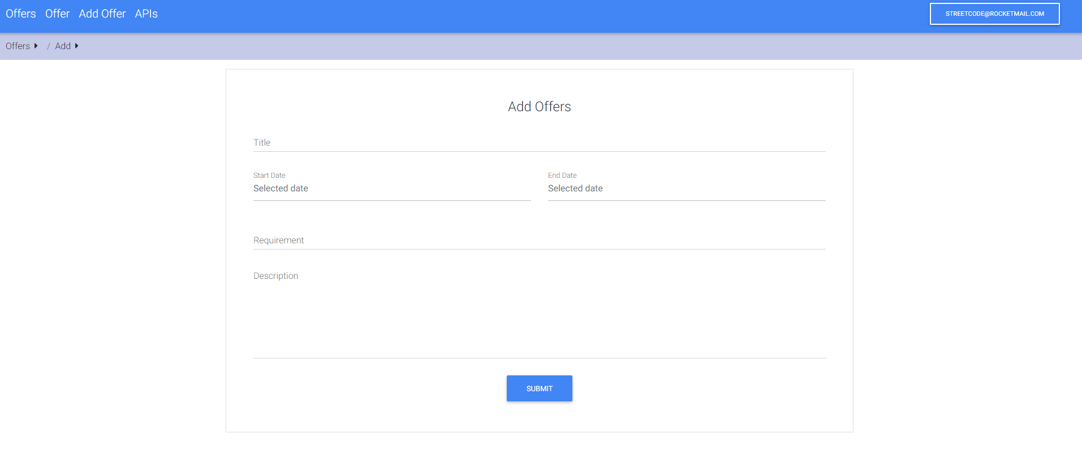

Click submit button after fill the form

## ADVISOR

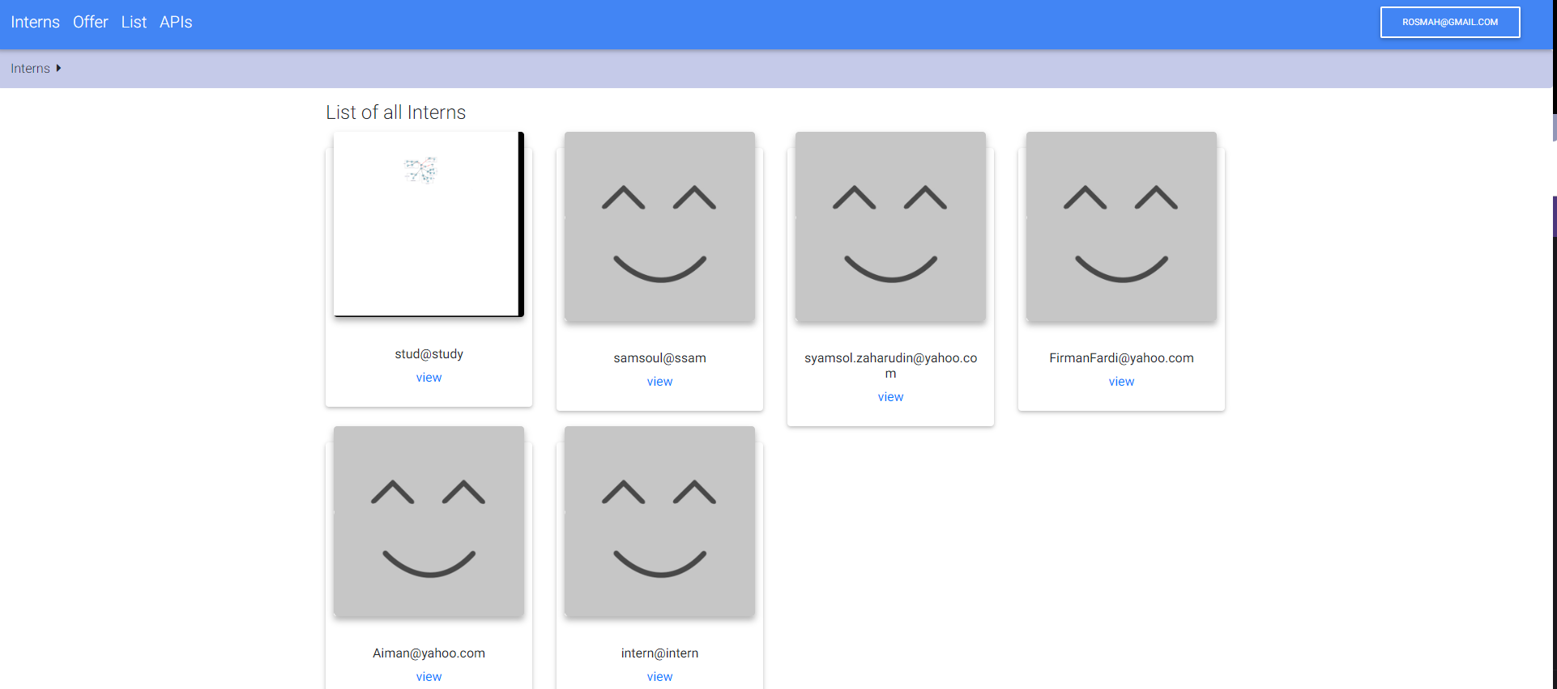If user enter as an advisor, users will be linked to list of interns.



Click the view button to view the details of the interns/students

## APIs

Company users only can view the list of APIs. Click the chosen API to view the details of selected API.

